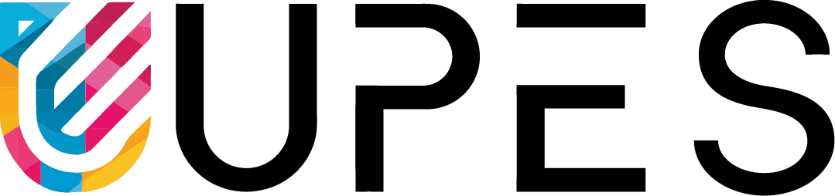

**Cloud Computing Architecture Lab**

**Name:** Pratham Kandari

**Sap Id:** 500097663

**Batch:** 7

**Experiment- 7**

Q:1. Explain the features of IAM in detail?

Ans:

IAM, or Identity and Access Management, is a system that allows you to manage access to resources within your organization. It provides a centralized and secure way to control who can access what resources and what actions they can perform on those resources. Here are some of the key features of IAM:

1. User Management: IAM allows you to create and manage users within your organization. You can define their roles and permissions, and control their access to different resources. You can also create groups of users with similar roles and permissions for easier management.
2. Role-Based Access Control: IAM uses a role-based access control model, which means that users are assigned roles that define what actions they can perform on resources. This makes it easy to manage access to resources for large organizations with many users and resources.
3. Multi-Factor Authentication: IAM supports multi-factor authentication, which adds an additional layer of security to the login process. This requires users to provide two or more pieces of evidence to verify their identity, such as a password and a code sent to their phone.
4. Resource Access Policies: IAM allows you to create resource access policies, which define who can access specific resources and what actions they can perform on those resources. This provides granular control over access to resources and helps to prevent unauthorized access.
5. Audit Trails: IAM provides detailed audit trails of user activity, which allows you to monitor who is accessing resources and what actions they are performing. This helps to identify any potential security breaches or policy violations.
6. Integration with Other Services: IAM integrates with other AWS services, such as Amazon S3 and EC2, allowing you to manage access to resources across your entire organization.

Overall, IAM provides a powerful set of tools for managing access to resources within your organization, helping to ensure that your data and systems are secure and that your organization is compliant with any relevant regulations.

Q:2. What is the difference between Root account, User account, Roles and Policies?

Ans:

Root accounts, user accounts, roles, and policies are all part of AWS Identity and Access Management (IAM) and play different roles in managing access to AWS resources. Here are the key differences between these concepts:

1. Root Account: The root account is the initial account created when an AWS account is set up. The root account has complete control over all resources in the account and should be used sparingly, as any actions taken by the root account are irreversible and cannot be audited. It is recommended that the root account be used only for initial setup and emergency situations.
2. User Accounts: User accounts are created within an AWS account and are used to grant access to specific resources. User accounts can be granted permissions based on their individual needs and can be managed centrally through IAM. User accounts are created with specific access keys and secret access keys, which are used to authenticate API calls and other programmatic access.
3. Roles: Roles are similar to user accounts but are meant for use by AWS services rather than individual users. Roles are used to grant access to specific AWS resources, and the permissions associated with a role can be assumed by AWS services on behalf of a user or resource. Roles are used to delegate permissions to resources that need to access AWS resources, such as EC2 instances or Lambda functions.
4. Policies: Policies are used to define permissions for users, groups, and roles. Policies are made up of statements that define the resources and actions that are allowed or denied for specific users or groups. Policies can be attached to users, groups, or roles, and multiple policies can be attached to a single entity.

In summary, root accounts have complete control over all resources in an AWS account and should be used sparingly. User accounts are used to grant access to specific resources and can be managed centrally through IAM. Roles are used to delegate permissions to resources that need to access AWS resources, and policies are used to define permissions for users, groups, and roles.

Q:3. What is the difference between the Management Console and Programmatic access?

Ans:

The AWS Management Console and programmatic access are two different ways to interact with AWS resources and services. Here are the key differences between them:

1. Management Console: The AWS Management Console is a web-based graphical user interface that allows you to manage AWS resources and services using a web browser. The Management Console provides an easy-to-use interface for managing resources, and you can perform tasks such as launching instances, configuring security groups, and managing storage directly from the console. The Management Console requires you to log in with your AWS account credentials, and all actions are performed through the console's web interface.
2. Programmatic Access: Programmatic access refers to the ability to interact with AWS resources and services through APIs, command-line interfaces (CLIs), or SDKs (software development kits). Programmatic access allows you to automate tasks and integrate AWS services into your applications and workflows. Programmatic access requires you to authenticate using access keys and secret access keys, which are used to make API requests or CLI commands. With programmatic access, you can perform tasks such as launching instances, creating buckets in Amazon S3, or managing databases through scripts or code.

Q:4. What is MFA in AWS?

Ans:

MFA in AWS stands for Multi-Factor Authentication, which is a security feature that adds an extra layer of protection to AWS accounts. MFA requires users to provide two or more pieces of evidence to verify their identity before they can access their AWS account or perform any sensitive operations. The two factors typically include something the user knows (such as a password or PIN) and something the user has (such as a physical device or token).

In AWS, MFA can be enabled for the root account, IAM users, and federated users. When MFA is enabled for a user, the user must provide a valid MFA code in addition to their password when they log in to their AWS account or perform any sensitive operations. The MFA code is typically generated by a hardware token, a software token on a mobile device, or received through a text message.

Enabling MFA is an important security best practice for AWS accounts, as it helps to protect against unauthorized access and security breaches. It is particularly important for high-risk operations, such as accessing sensitive data, making changes to security settings, or performing administrative tasks. AWS provides a range of options for implementing MFA, including hardware tokens, software tokens, and SMS-based MFA.

**Identity Access Management in AWS**

1. Create user, role and policies and access it through Management Console and CLI
2. Show how to use MFA in IAM?

